Windmill Energy

Subject: Physics, Math, Energy  Related Subjects: Civil Engineering | Grade Level(s): All grades  Length of Lesson: 30-45 minutes | Type: Project  Keywords: Kinetic Energy, Power, Torque, Speed

Lesson Overview
Create a windmill powered by a 9 inch fan to lift the most weight. Wind mill is usually measured by the power meaning energy it produces per second from wind. In this experiment we will measure power using the physical approach. Lifting weight a certain distance requires energy and the faster this distance is traveled the higher the wind turbine’s power is. So keeping this in mind, we will explore different shapes, numbers and sizes of blades to get the maximum power generation from the turbine.

Lesson Focus
The central focus of the phenomenon that is investigated is how efficient can the windmills function with respect to size of the blades, number of blades, orientation of blades, and ratio of turning mechanisms.

Lesson Objective(s) | Create a windmill powered by a box fan to lift the most weight.

Lesson Timing
5 minutes | Introduce the Lesson
5 minutes | Handout Materials to Students
10-15 Minutes | Time for Students to build!
15 Minute | Testing of the Windmills
5 Minutes | Assess & Evaluate
5 Minutes | Lesson Cleanup

Introduction to Windmill Energy Activity 1
Materials | - Scissors  - String  - Masking tape  - 3x5 Index cards  - Film canister and lid  - Plastic cup  - 8 - 5 1/8 ” K’Nex Rod (green)  - 4 - 7 1/2 ” K’Nex Rod (gray)  - 8 - 3 7/16 ” K’Nex Rod (yellow)  - 4 - Circular connector (white)  - 4 - Semi-circular connector (yellow)  - 8 - Clip connector  - 1 - 20g weight  - 3 - 10g weight  - 5 - 5g weight  - 10- 1g weight
Instructor Prep | Weights and Space available for testing at the end
Related Resources | - Exploratorium Experiment  - Instructables Experiment

Introduction to Windmill Energy Activity 2
Materials | - Foam board  - Wood dowels  - Film canisters  - Scissors  - Hot glue  - X-acto or box cutter  - Electrical tape  - String  - Cups and rocks for weight  - Fan
Related Resources | - Exploratorium Experiment  - Instructables Experiment

Lesson Plan

Introduction
Type of windmill:
A vertical axis is mainly used for torque, and a horizontal is used for speed.

Size of windmill blades
Larger blades have a greater swept area and thus catch more wind with each revolution. Because of this, they may also have more torque.

Number of windmill blades
A significant factor determining the efficiency of windmills is the number of blades: more blades capture more energy. However, there is a trade off with weight and initial inertia to start the windmill. In addition, there is a law of diminishing returns (not getting any additional benefit) for adding more blades.

Shape of Blades
If an optimum blade shape is discovered, then the overall productivity of a windmill can be increased.

Possible blade shapes are as follows:
- Flat, unmodified blade surface;
- Wing shape, with one leading edge rounded with the other edge tapered to a thin line;
- Both edges tapered to a thin line; and
4. Both edges rounded like the leading edge of a conventional airplane wing.

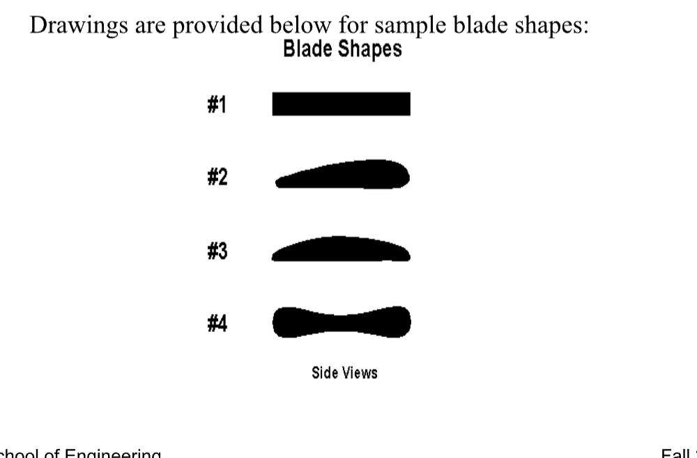

Procedure
- Insert a blue rod into one side of a yellow connector.  - Insert a gray rod into the other side of the yellow connector.  - Insert the other end of the gray rod into the side of a green connector  - This is a base  - Repeat steps 1 to 3 to create a second a second base | 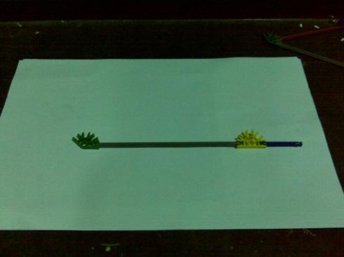
- Insert a red rod into a slot right next to the opening on the blue connector  - Insert a second red rod into the other slot right next to opening  - This is your angled support  - Repeat steps 6 & 7 to create a second angled support | 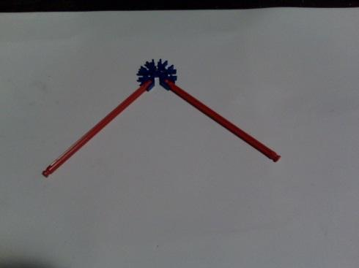
- Connect an angled support to a base by inserting the red rods to the green and yellow connectors as shown in the picture to create a “foot”  - Repeat for the other angled support and base to create another “foot” | 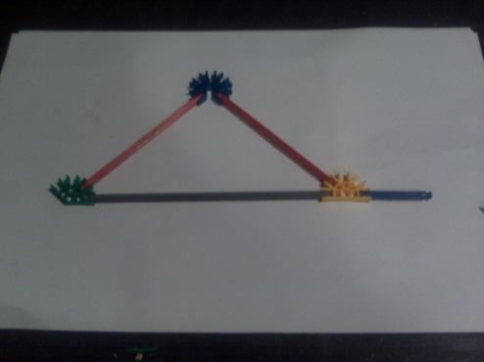
- Stand each foot so blue connectors face up  - Connect the two “feet” by inserting a gray rod into the slots behind the top slots of each of the blue connectors  - Insert another gray rod into the open front slot of the yellow connectors of both “feet” (immediately above the horizontal slot)  - This is the windmill base | 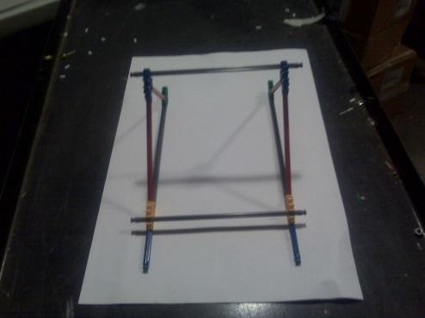
- Insert a blue rod into each end of an orange connector  - Insert other end of each blue rod to the outside end of a red connector  - Repeat with identical components to create another “bridge” | 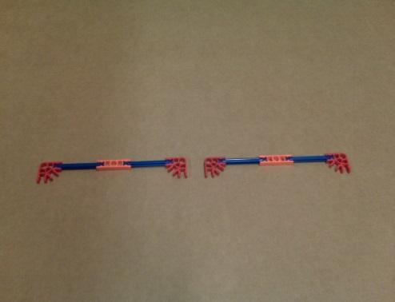
- Insert gray rods into the bottoms of the red connectors to form the front bridge  - Insert yellow rods into the bottoms of the other connector to form the back bridge | 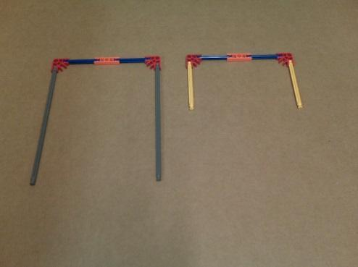
- Attach front bridge to the front of the windmill base by inserting the gray rods into the top slots of the yellow connectors  - Attach back bridge to the rear of the windmill base by inserting yellow rods into the top slots of the blue connectors | 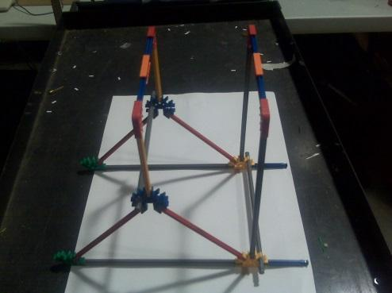
- Attach tan connector (pointing outward) 1.5cm from the edge of a gray rod) | 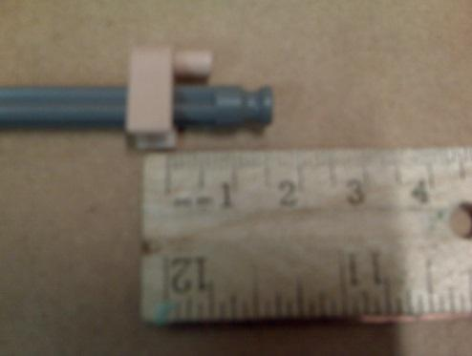
- Insert the same end through the center of a white connector | 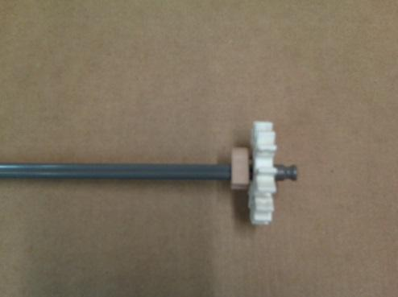
- Attach the gray connector to the end of the gray rod extending out of the white connector | 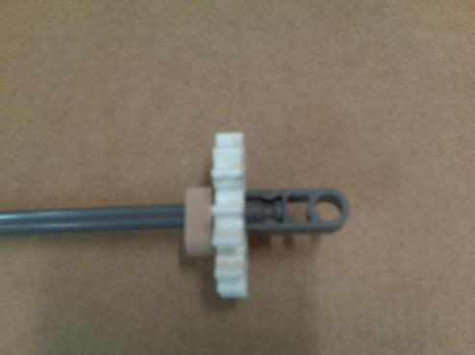
- Insert the yellow rods into the white connector 90° apart.  - This is the blade mechanism | 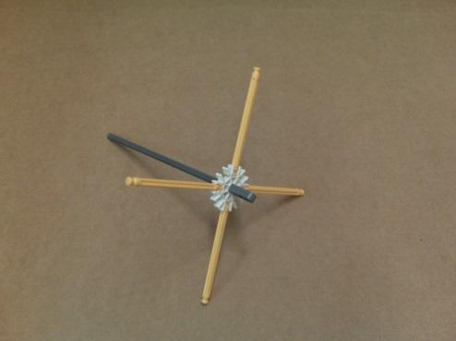
- Insert the free end of gray rod of blade mechanism through the hole in the orange connector front bridge and through the hole in the orange connector back bridge  - Snap the second gray connector to the gray rod of the blade mechanism to keep it from sliding back too far and causing the blades to strike the structure | 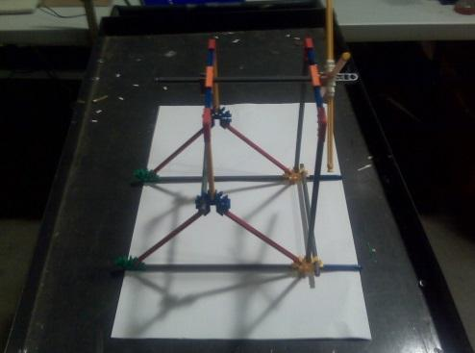  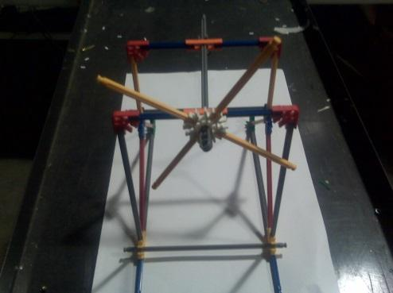

Front view

Enlarged view

Top of Table

25 cm

Device Area

Activity 2 – Create the Blades and Lifting Object

- Remove the 4 yellow rods of the blade mechanism
- Using the 4 removed yellow rods and 4 additional yellow rods for a total of 8 blades, tape a 3x5 card to each of the yellow rods. The bottom edge of the card should line up with the end of the groves in the rod.
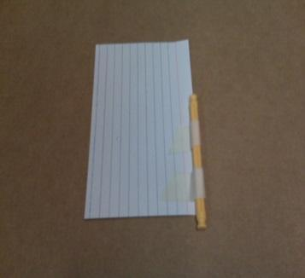
- Tape a piece of balsa wood to the back to give the each blade extra support (width of card)
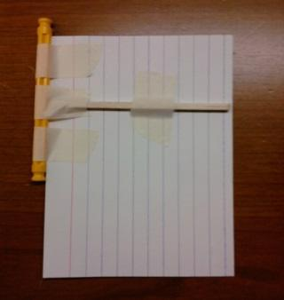
- Cut a string 1.25 meter long
- Under the rim of a 3oz cup, punch two holes across from each other, using a pencil
- Insert string through the holes and tie so that the cup is suspended from the string
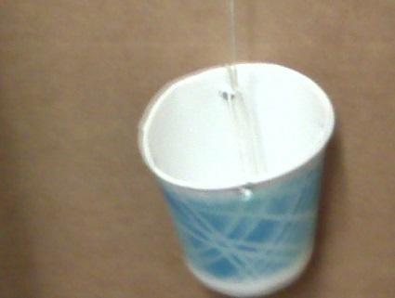
- Place the windmill on the table, in the device area, with the back end hanging over the edge.
- With the cup resting on the floor, tape the other end string to the back end of the gray rod of the blade mechanism.

Wrap-up
Tower Design - Towers are important in the construction of the windmill because not only do they have to support the windmill, but they must also be subject to their own weight and the drag of the wind and torque from the blades.
Angles or orientation of windmill blades - The angle or orientation of the blades is one factor in optimizing the efficiency of the windmill in “capturing” the wind.
Height of windmill axis - The optimal position is at the center of the axis of the box fan. This ensures the windmill “captures” the most amount of wind and in the optimal direction (parallel).
Ratio of turning mechanisms to axis - The ratio of the turning mechanism (pulley) to the axle of the windmill is the mechanical advantage from the applied force. You must balance the initial resistance to start with the advantage of multiplication of force.
- Bicyclists use low gear up hill
  - Pedals turn more for fewer wheel turns.
  - Large mechanical advantage
  - Gear &amp; Axle or Axle &amp; wheel almost same size
- For speed use high gear
  - Many wheel turns per pedal
  - Small mechanical advantage
  - Gear much smaller than axle which is much smaller than wheel.
- Best of both worlds
  - Gear shift maximizes both
  - Large pedal turns small axle turns larger wheel

Lesson Background for Teachers

Lesson Variations and Options
- Time Trials: Instead of lifting the most weight, students could race to lift a fixed weight the fastest.
- Blade Material Variation: Allow testing of other lightweight materials (e.g., paper or plastic).
- Blade Design Challenge: Students can compete using a set number of blades, experimenting with shapes.
- Team Collaboration: Assign different roles (designer, builder, tester) to emphasize teamwork and STEM careers.

Explanation
Windmills convert kinetic energy from the wind into mechanical energy. The fan acts as the wind source, pushing against blades that are angled to catch airflow. As the blades spin, they rotate a dowel or axle, winding up a string that lifts a weighted cup. Optimizing the size, shape, and orientation of the blades affects how much energy is captured. Additionally, using spools or pulleys affects torque and mechanical advantage—concepts central to physics and engineering.

Key Concepts and Vocabulary
- Torque: The twisting force that causes rotation.
- Lift: To raise or move something upward.
- Kinetic Energy: The energy an object has because it's moving.
- Mechanical Advantage: A way machines make work easier by increasing force or changing direction.

Safety Notes
- Keep fingers away from moving blades and cutting surfaces.
- Allow hot glue to cool before touching glued areas.
- Ensure the fan is securely placed and cannot fall or blow loose parts around.

